SEBC : - EXIT TEST

1. Created new instances

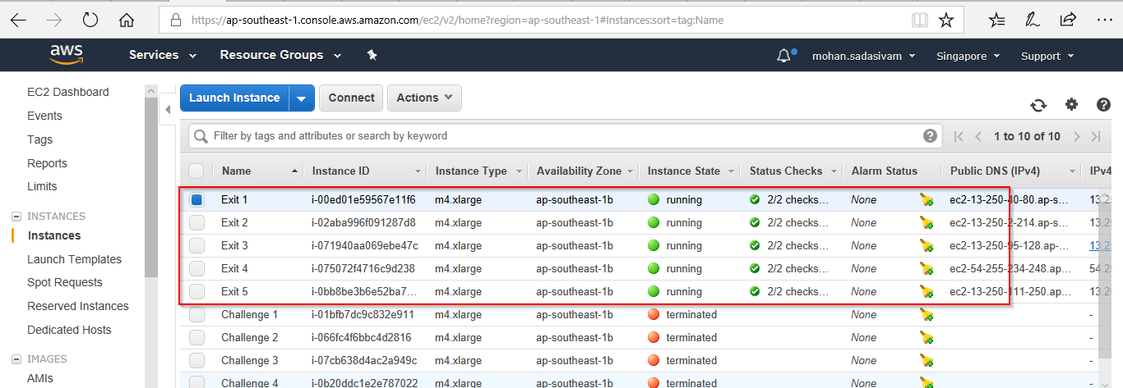

1. Completed Pre-requisites in all the Nodes
2. Installed httpd service on Master Node where cloudera manager is to be placed

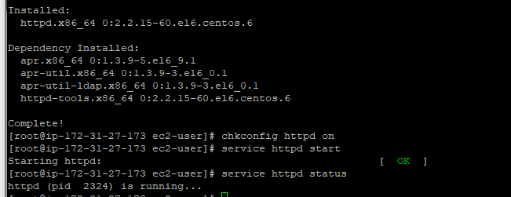

1. Installed MySQL and its connector.



1. Created databases